**MIDDLE EAST TECHNICAL UNIVERSITY**

**DEPARTMENT OF ELECTRICAL AND ELECTRONICS ENGINEERING**

**EE463 - STATIC POWER CONVERSION I**

**Hardware Project Simulation Report**

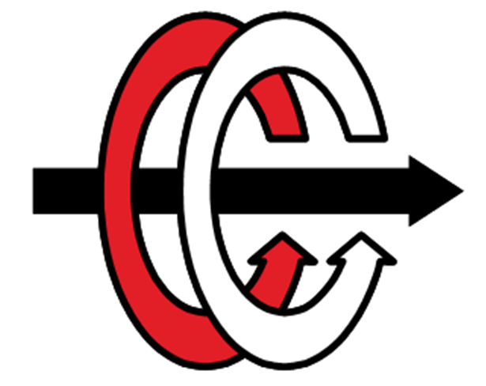

**CEMAL ÖZTÜRK - 2041887**

**CEMİL ÜRGÜP - 2095040**

**HABİBULLAH KOÇOĞLU - 2094191**

**Table of Contents**

Introduction……………………………………………………………………………………………….……3

Converter Topologies and Selected Topology…………………………………………….……3

Simulation Results……………………………………………………………………………………..……4

H-Bridge and Four Quadrant Motor Operation………………………………………………11

References……………………………………………………………………………………………….……12

# **Introduction**

In this report, a DC motor driver circuit which converts three-phase AC voltage to DC will be suggested. In this topology, a full bridge diode rectifier will be used as an AC to DC converter and a buck converter is used as a DC to DC converter to drive the DC motor and make its speed control. The main advantage of this configuration is that the input DC voltage of the buck converter is supplied by the full bridge rectifier which does not require any triggering pulses which makes the design more complex. Also, the buck converter output DC voltage amplitude could be controlled by a feedback control circuit between output and the PWM modulator to keep the output DC voltage at desired level. Moreover, to make for quadrant operation to rotate the motor in both directions an H bridge rectifier can be used.

## **Converter Topologies and Selected Topology**

We have some main topologies which are half wave controller rectifier, full wave controller rectifier and buck converter can be usable for this project. There are many topologies, but we focused on only mentioned three of them. We selected our topologies according to some general points like simplicity, and bonuses which mentioned below.

Half wave controller rectifier looks like simpler than other topologies. However, controlling of thyristor is very problematic event. Thyristor driver IC is available, but driver of this circuit is very complex. Driving thyristor by using Arduino is possible but Arduino will not be effective for this current and speed probably. Analog driver is possible making trigger for thyristors. It looks like possible by connecting capacitor to gate of thyristor. However, this is foreign and dangerous method because gate voltage can be greater than cathode voltage this can damage thyristor. Also, harmonics are very problematic in wave rectifiers. However buck converter has no much harmonics. In buck converter , opening MOSFET is very basic from triggering of thyristors. Because of these reasons we decided to use Buck converter for our purpose. Our whole circuit schematic can be seen from Figure 1.

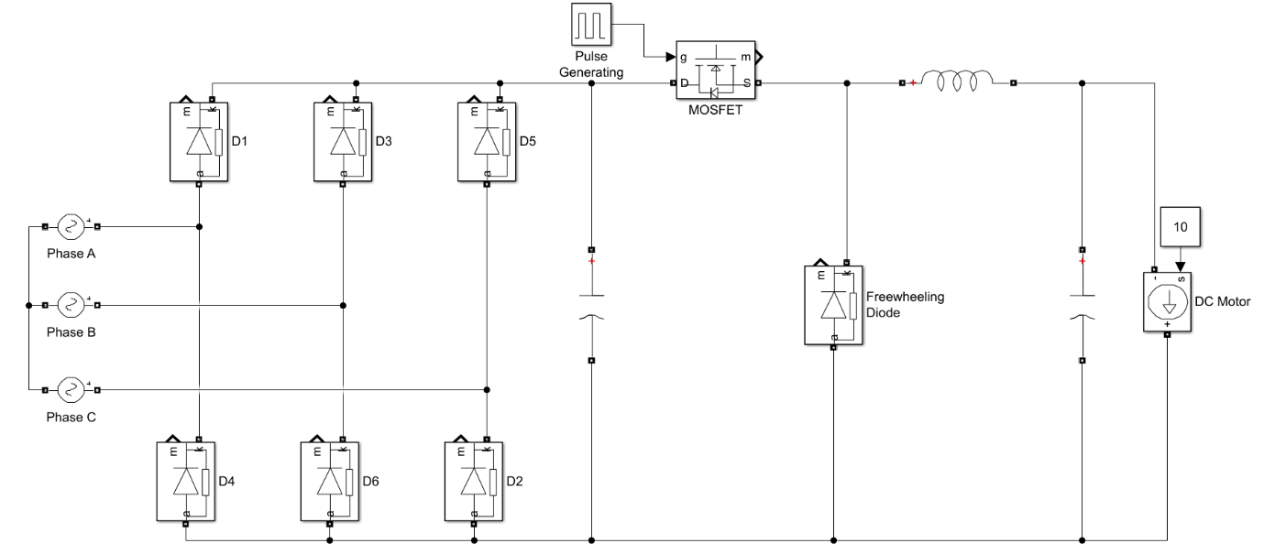

**Figure 1:** 3-Phase Full Bridge Diode Rectifier with Buck Converter

**Simulation Results**

In this part, we simulated our circuit by using Simulink. Simulation is important part of this project because before hardware implementation, it allows us to see our mistakes. In order to obtain desired results some of the parameters was changed during simulation. Our Simulation schematic can be seen from Figure 2. We used proper components and blocks in our simulation and we also used DC Machine component in order to obtain more realistic results.

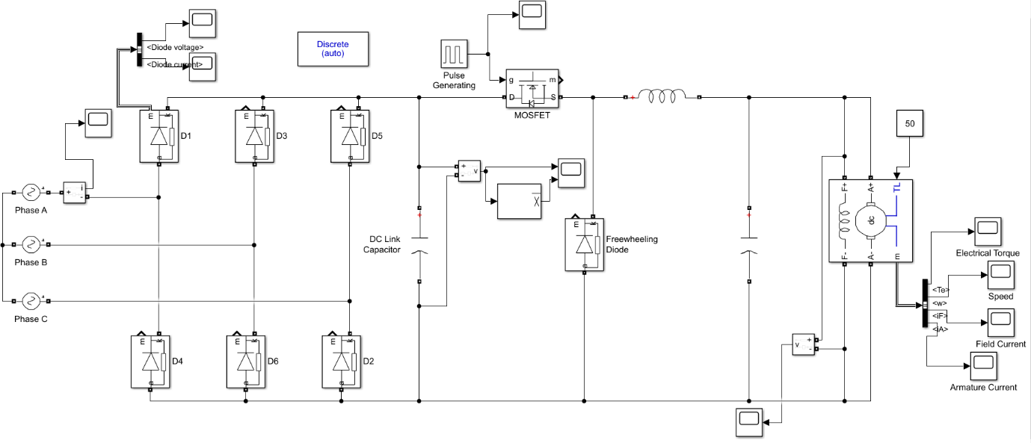

**Figure 2:** Simulation Diagram from Simulink

Note that input voltages in our simulations are 230 Volts RMS with 120O phase difference.

Firstly, we simulated only 3-phase full bridge diode rectifier with resistive load and then we added DC link capacitor so that we could see the effect of DC link capacitor. Output voltage is in Figure 3.

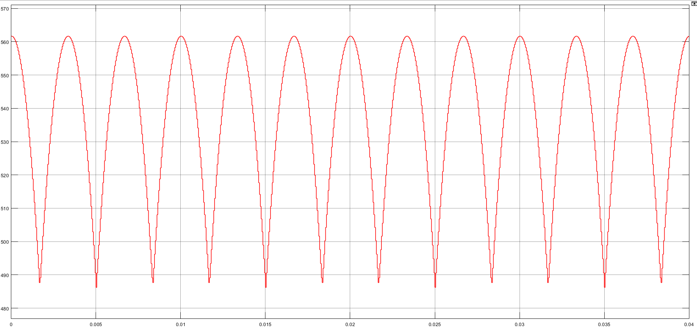

**Figure 3:** Output Voltage of 3-Phase Full Bridge Diode Rectifier

As can be seen, there is voltage ripple which in between 496 – 560 Volts. This kind of ripple is not good for operation. Therefore, adding DC link capacitor to output is good idea to eliminate this undesired ripple. Output voltage with DC link capacitor added can be seen from Figure 4.

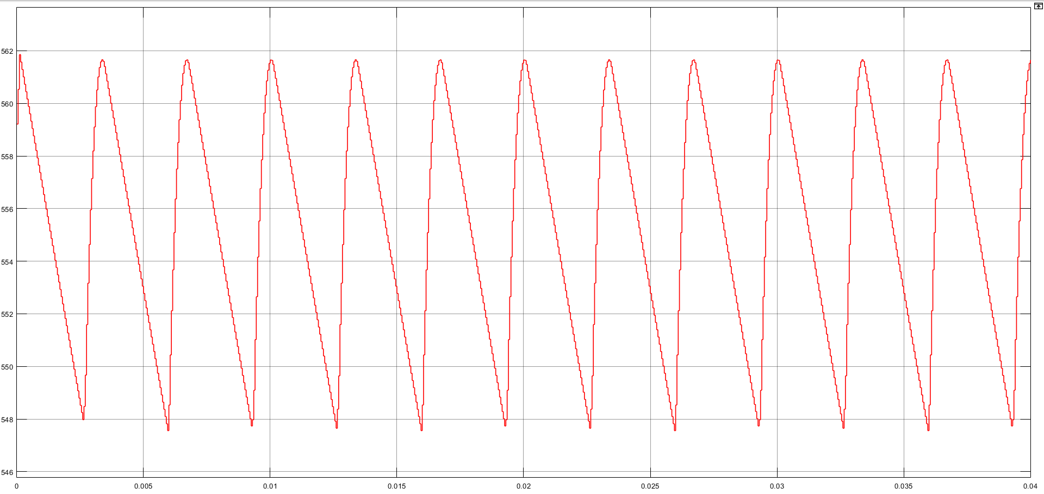

**Figure 4:** Output Voltage of 3-Phase Full Bridge Diode Rectifier with DC Link Capacitor

With output capacitor voltage ripple in the circuit dropped to 548 – 562 voltage band which is good value for 562 Volts peak value.

After putting DC link capacitor to output of 3-phase full bridge diode rectifier, we added buck converter to our circuit. For switching of converter, we preferred MOSFET with gate trigger. Gate trigger of the MOSFET comes from pulse generator block diagram in Simulink. By changing duty cycle of this pulse, we can change average value of DC output. Changing DC output voltage is important in this project because motors draws high current at the beginning of the operation. In order to prevent from this current, we should start our motor softly by changing duty cycle of MOSFET.

To observe our circuit for different operations, we used different duty cycles which are 10%, 50% and 90%. Output voltage of buck converter, motor speed and armature current of motor schematics can be seen from following figures.

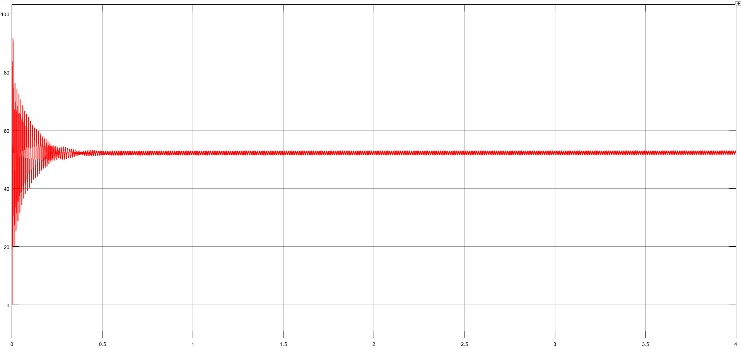

**Figure 5:** Output Voltage of Buck Converter with 10% Duty Cycle

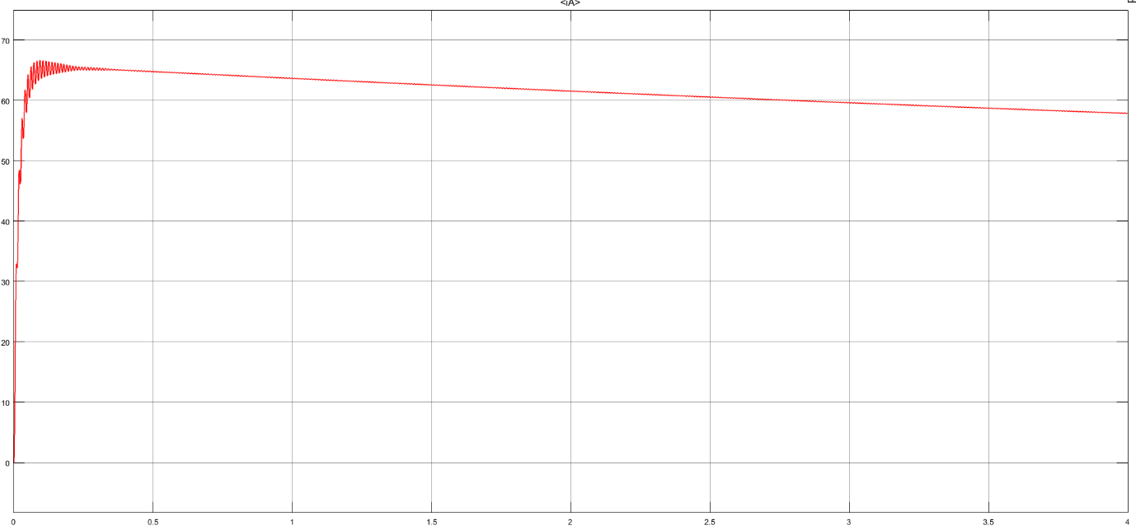

**Figure 6:** Armature Current of Motor with 10% Duty Cycle

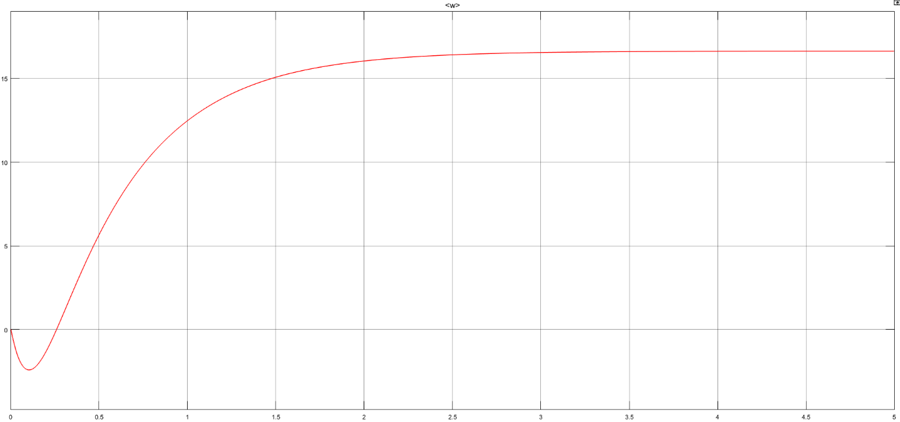

**Figure 7:** Motor Speed(ω) with 10% Duty Cycle

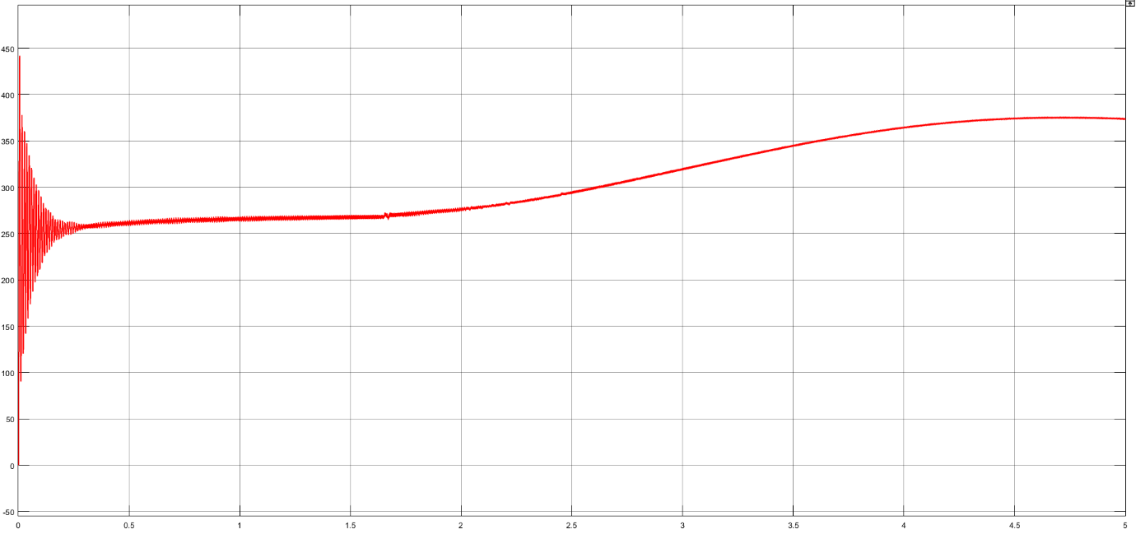

**Figure 8:** Output Voltage of Buck Converter with 50% Duty Cycle

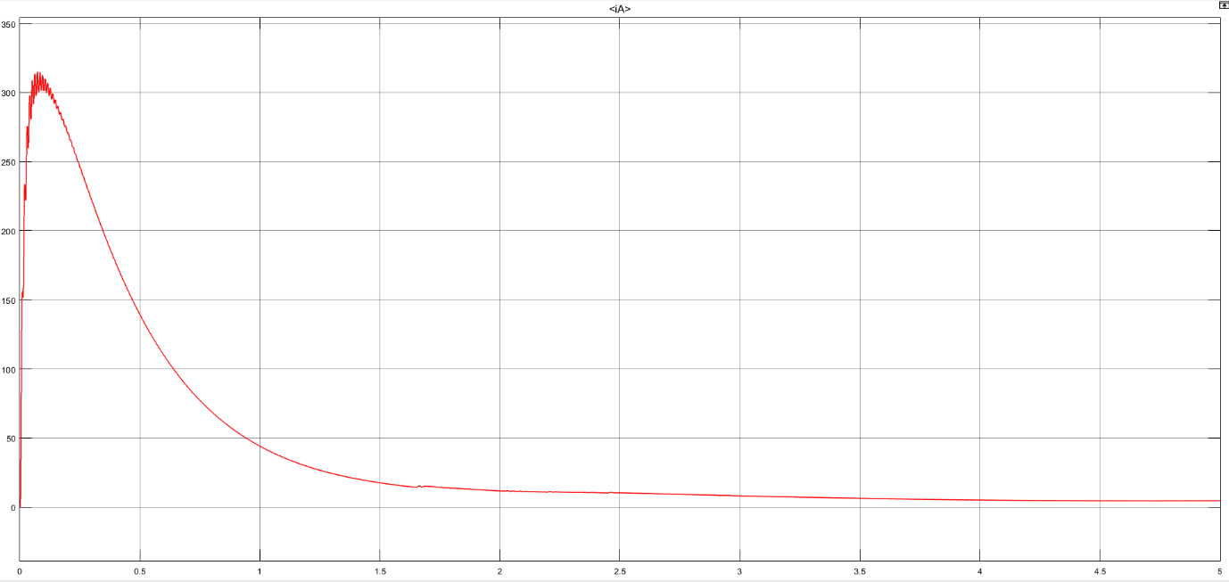

**Figure 9:** Armature Current of Motor with 50% Duty Cycle

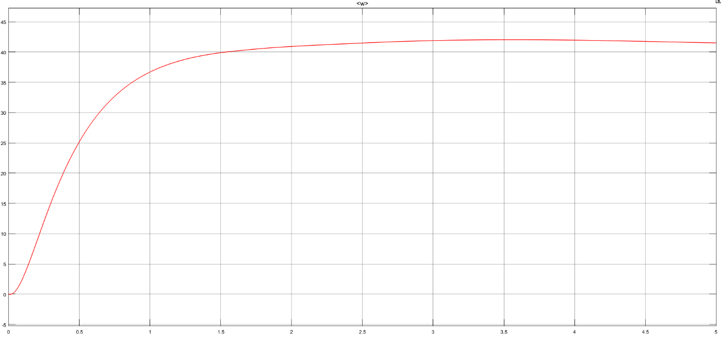

**Figure 10:** Motor Speed(ω) with 50% Duty Cycle

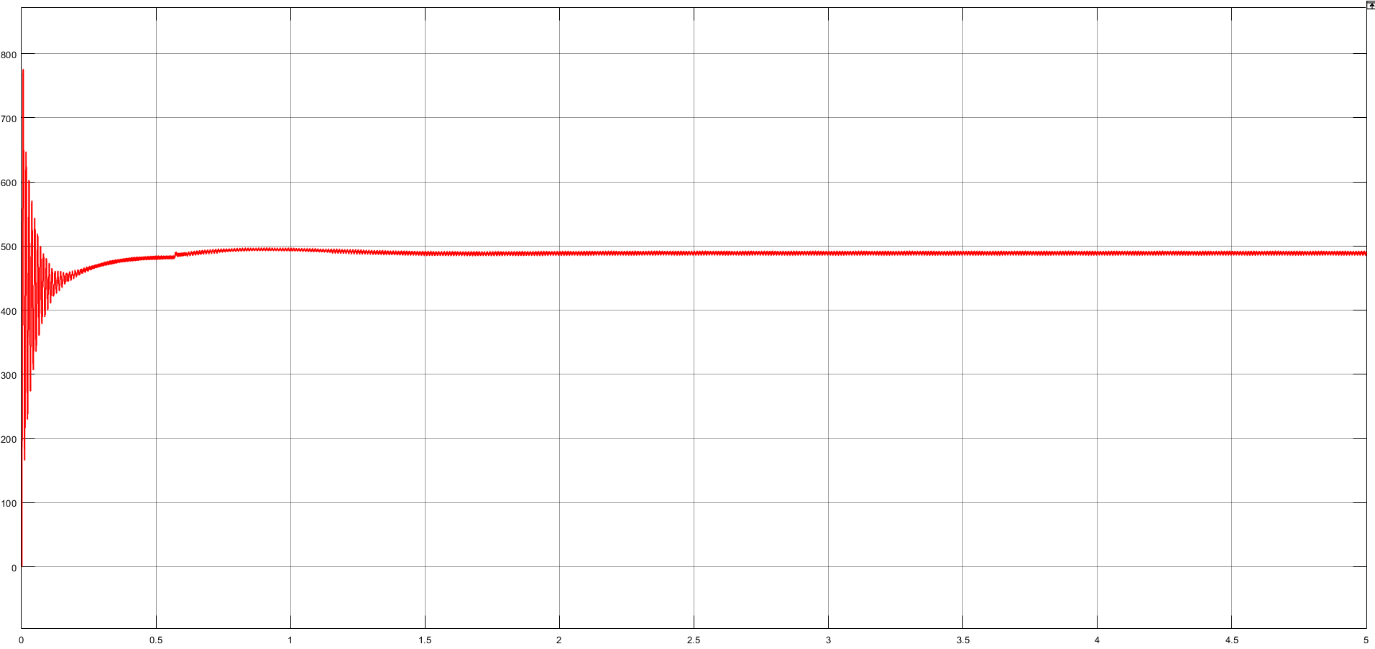

**Figure 11:** Output Voltage of Buck Converter with 90% Duty Cycle

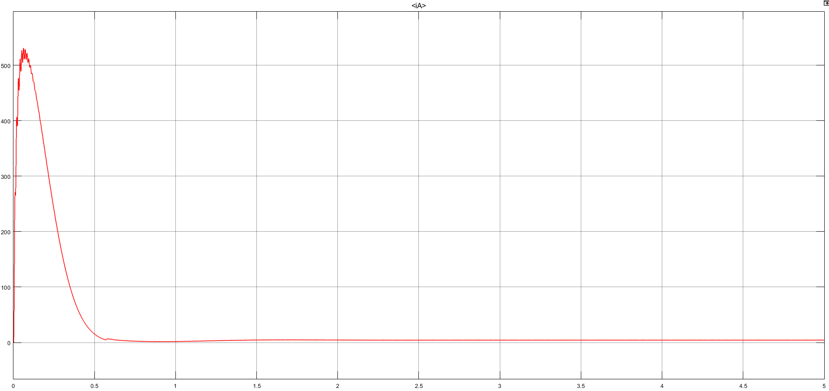

**Figure 12:** Armature Current of Motor with 90% Duty Cycle

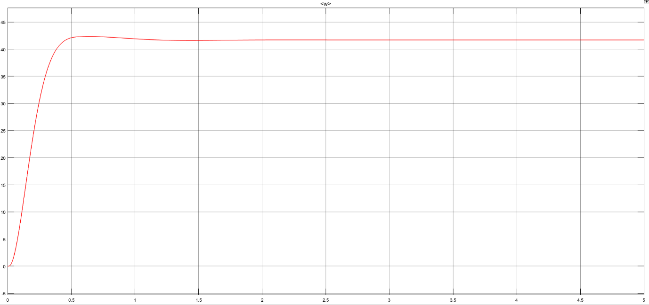

**Figure 13:** Motor Speed(ω) with 90% Duty Cycle

As can be seen, motor speed increases with duty cycle of MOSFET gate signal as expected. Another observation from simulation results is that, when we increased duty cycle, starting output voltage and output current is high. Actually, this is why we need soft start by changing duty cycle. In 10% duty cycle, peak value of armature current is roughly 70 A. This value is 300 A and 500 A for 50% and 90% duty cycles respectively.

**H-Bridge and Four Quadrant Motor Operation**

Four quadrant operation of DC motor is forward motoring, forward breaking, reverse motoring and reverse breaking. In order to drive DC motor in all of these operations, motor should turn both clockwise and counterclockwise. Since in our design we only give positive voltage to terminal of motor, we cannot obtain four quadrant operation without any external circuitry or integrated circuit. For that purpose, we found a solution which is h-bridge. Circuit schematic of h-bridge can be seen from Figure 14.

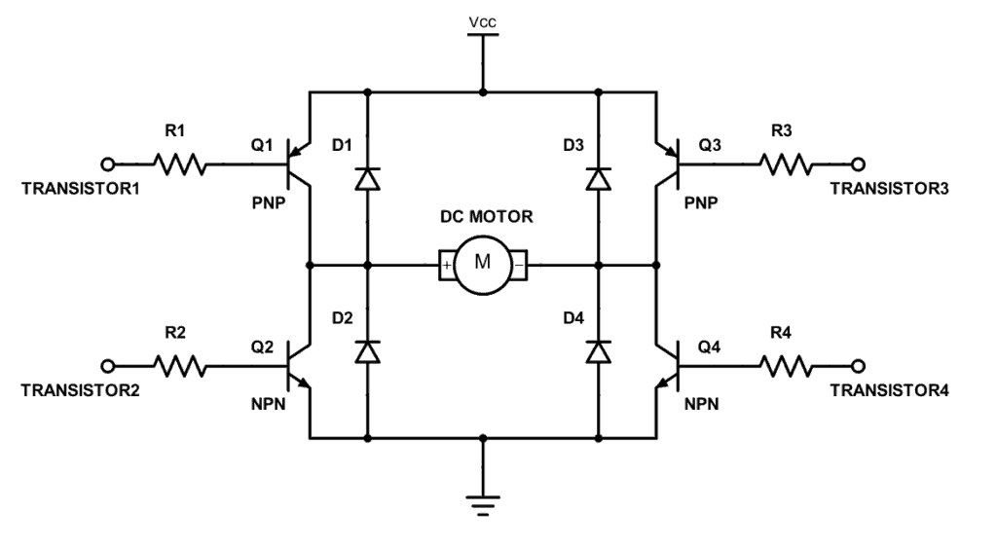

**Figure 14:** Circuit Schematic of H-Bridge

Working principle of h-bridge is simple. If Q1 and Q4 transistors are in contact and Q2 and Q3 is off, positive current flows from the motor and motor rotates according to that direction. If Q2 and Q3 transistors are in contact and Q1 and Q4 is off, negative current flows from the motor and motor rotates reverse direction. Purpose of diodes in this circuitry, is protection. Since motor is highly inductive load, in case of accidentally open-circuited motor because of inductors current cannot be dropped to 0, this situation causes burning of motor.

**References**

[1] Three Phase Rectification, [Online]. Available: https://www.electronics-tutorials.ws/power/three-phase-rectification.html

[2] Buck Converters, [Online]. Available: http://www.learnabout-electronics.org/PSU/psu31.php

[3] What is an H-Bridge?, [Online]. Available: https://www.build-electronic-circuits.com/h-bridge/